How to Join the Sophos MTR - EAP Microsoft Graph Security EAP

STEP 1 - Enter the invitation code in the Central

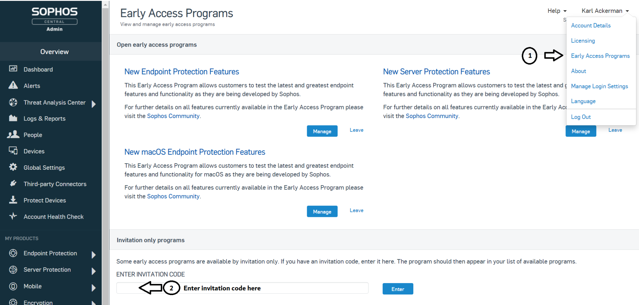

STEP 2 - The early access program should become available and you need to JOIN the program

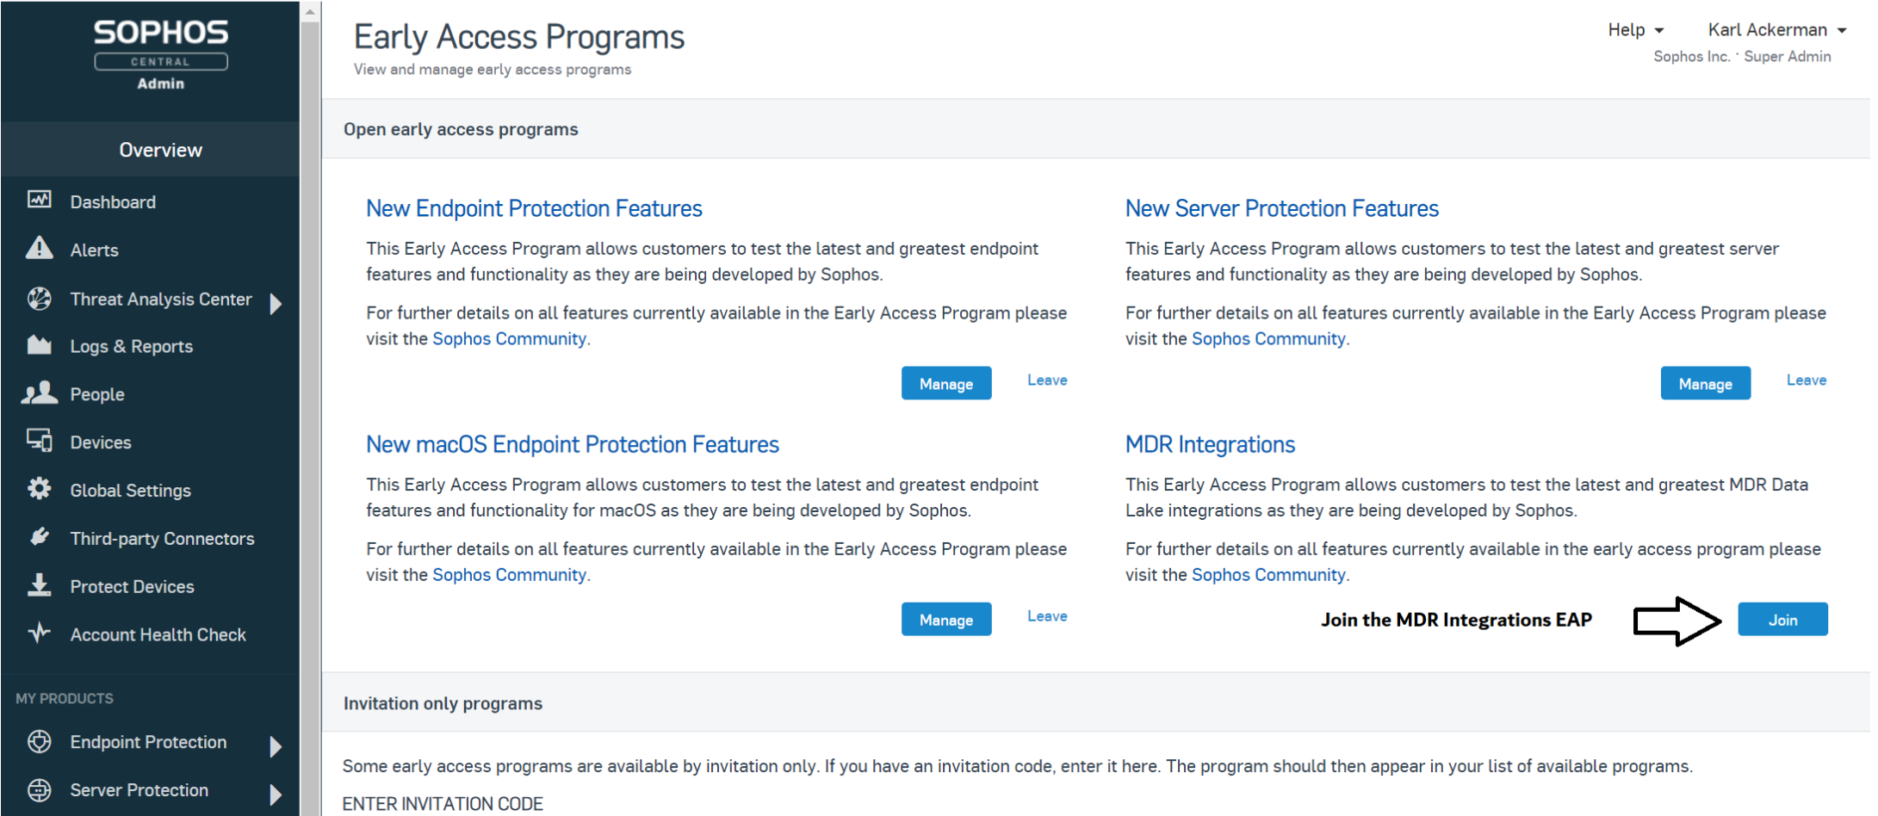

STEP 3 - Review and Accept the terms and conditions for the EAP.

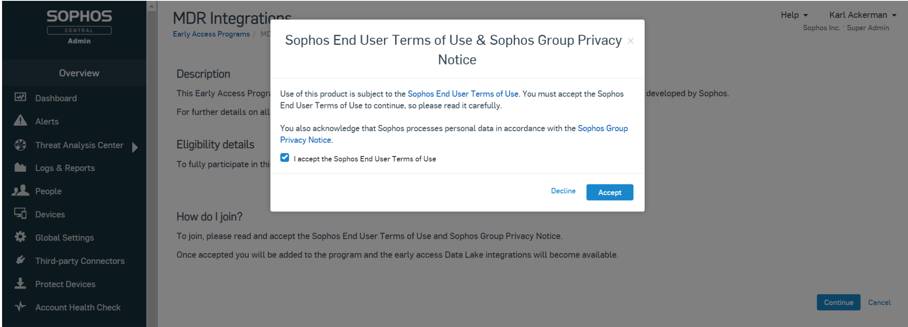

STEP 4 - Now select Third-party Connectors from the left side navigation in central and select the Microsoft Graph Security alerts connector

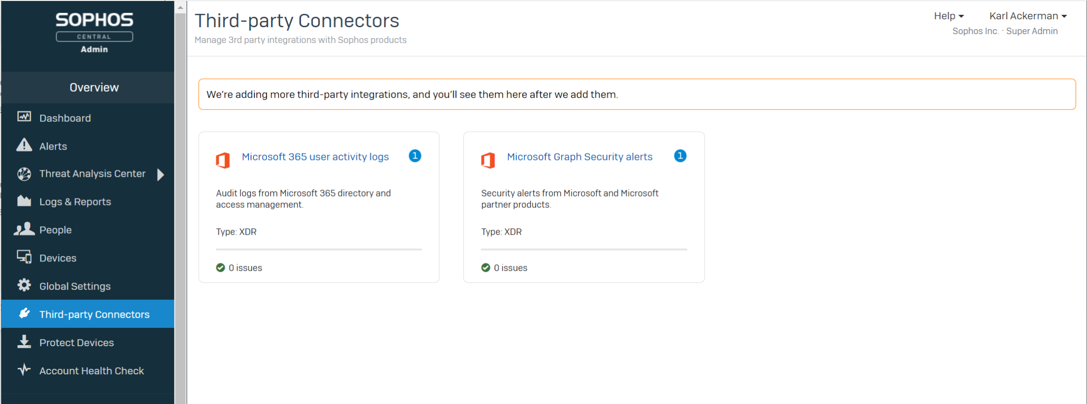

STEP 5 - Add the connector

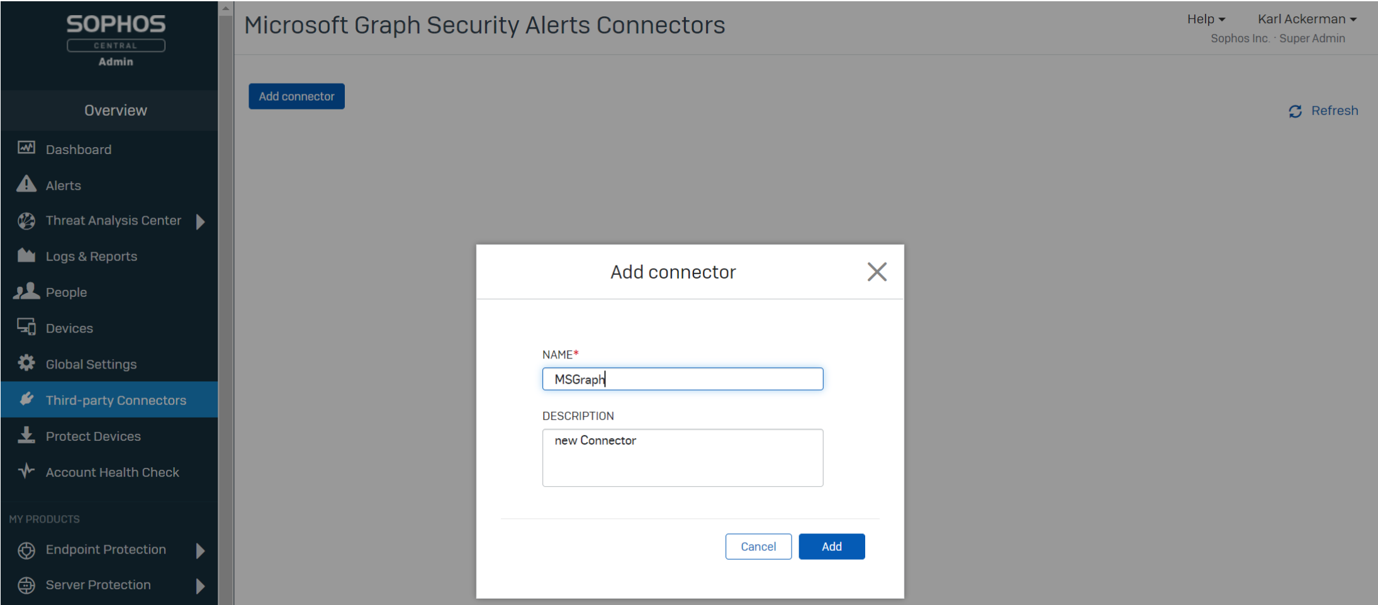

STEP 6 - Select continue and you will be prompted for your Microsoft Security Center password.
- We are not storing your account credential; You are simply authorizing Sophos to setup a read-only connection the the MS Graphs Security API.
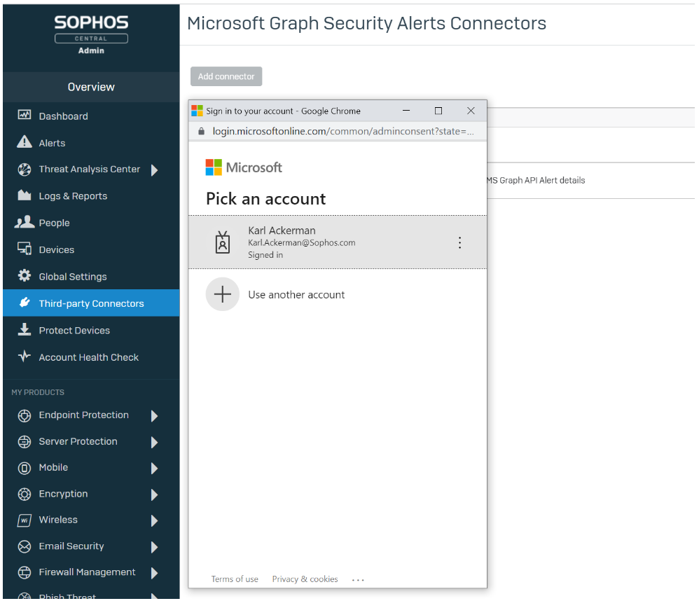
STEP 7 - Confirm the connector is working correctly
After the connector, has been configured it will take some time before the first MS Graph alerts will be visible. Depending on the activity in your environment this may be from a quickly as 15 min to much longer if no detections are being generated.

If the connection fails please reach out to us at mdreap2@sophps.com with the details.
You can check the status of the connector and see how many alerts have been synchronized.
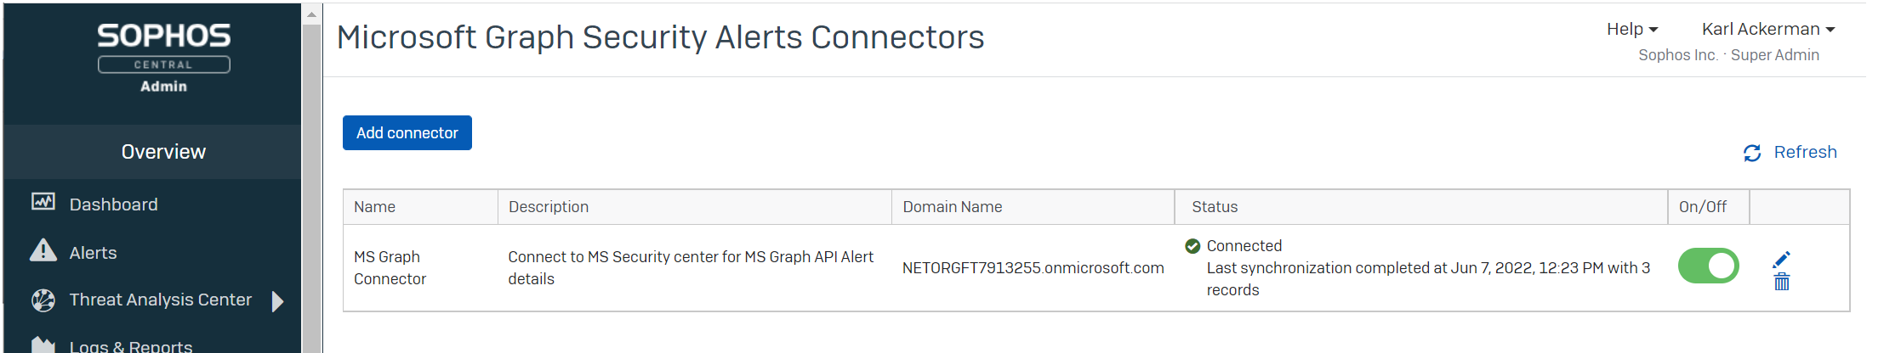

STEP 8 - After you have confirmed events are being synchronized you can view the detection by running a query in central.

Simply navigate to Threat Analysis Center -> Live Discover enable designer mode and add a new DataLake query.
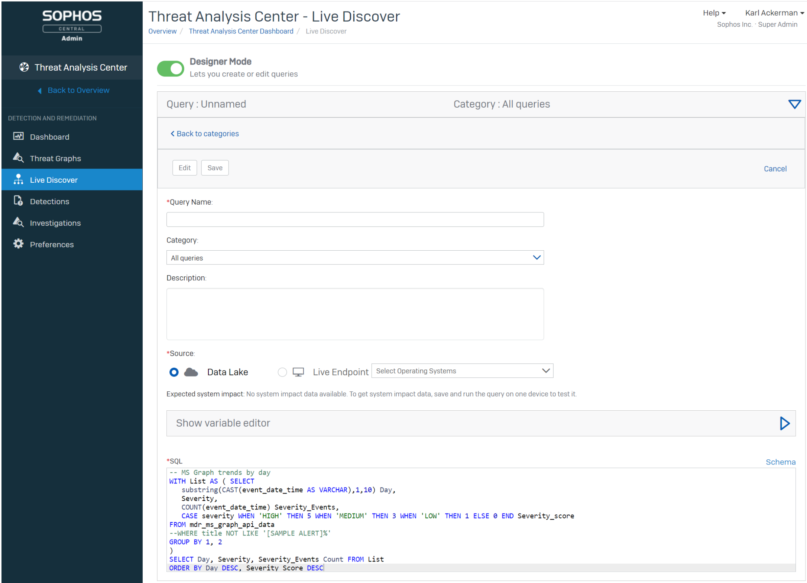

SQL CODE TO ADD:
-- MS Graph trends by day
WITH List AS ( SELECT
substring(CAST(event_date_time AS VARCHAR),1,10) Day,
Severity,
COUNT(event_date_time) Severity_Events,
CASE severity WHEN 'HIGH' THEN 5 WHEN 'MEDIUM' THEN 3 WHEN 'LOW' THEN 1 ELSE 0 END Severity_score
FROM mdr_ms_graph_api_data
--WHERE title NOT LIKE '[SAMPLE ALERT]%'
GROUP BY 1, 2
)
SELECT Day, Severity, Severity_Events Count FROM List
ORDER BY Day DESC, Severity_Score DESC

Additional queries are available on the community forum.

For more information on the Microsoft Graph Security Connector
- Sophos MDR Community forum: https://community.sophos.com/mdr-community-channel
- Sophskills presentation: https://community.sophos.com/mdr-community-channel/mtr-connector-eap/b/announcements/posts/presentation-deck-from-sophskills-for-ms-graph-connector
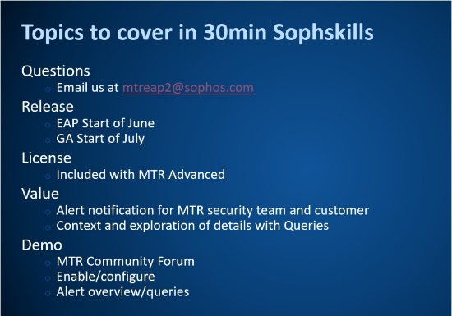 | Presentation Deck from Sophskills for MS Graph Connector  Attached below is the presentation deck used in the Sophskills demo from June 1 and 2.  community.sophos.com


