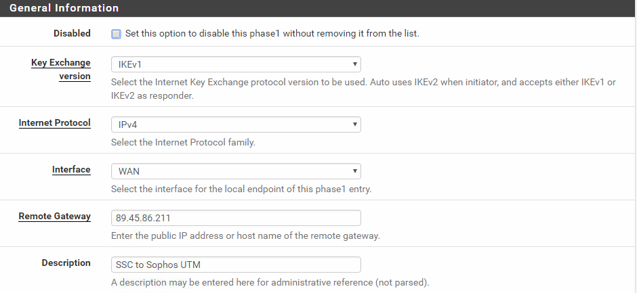

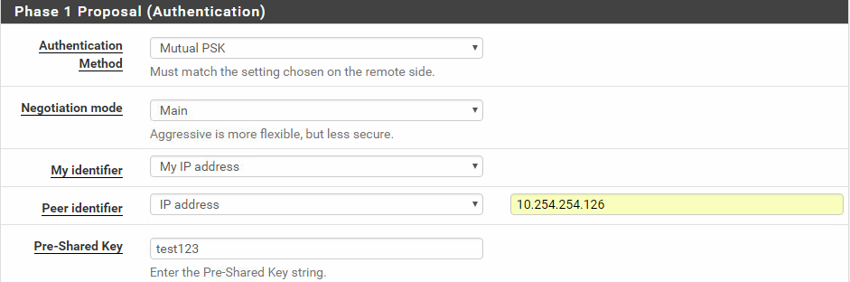

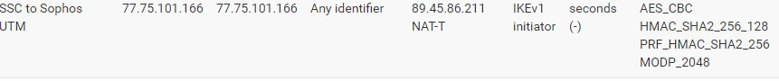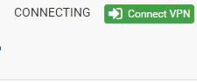
After 2 minutes or so, it disconnects.

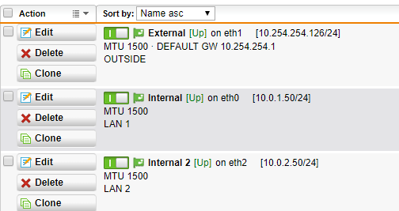

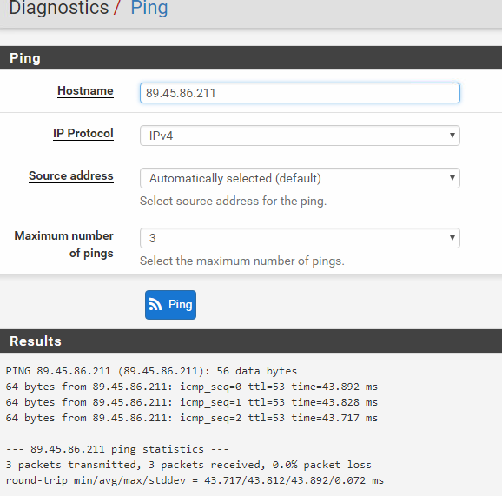
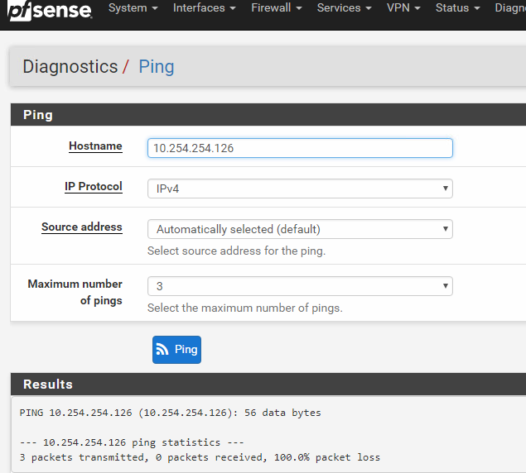

2017:12:05-10:04:37 89 pluto[5611]: "Office1" #403127: initiating Main Mode
2017:12:05-10:04:37 89 pluto[5611]: added connection description "Office1"
2017:12:05-10:04:37 89 pluto[5611]: "Office1" #403127: received Vendor ID payload [XAUTH]
2017:12:05-10:04:37 89 pluto[5611]: "Office1" #403127: received Vendor ID payload [Dead Peer Detection]
2017:12:05-10:04:37 89 pluto[5611]: "Office1" #403127: received Vendor ID payload [RFC 3947]
2017:12:05-10:04:37 89 pluto[5611]: "Office1" #403127: enabling possible NAT-traversal with method 3
2017:12:05-10:04:37 89 pluto[5611]: "Office1" #403127: NAT-Traversal: Result using RFC 3947: i am NATed
2017:12:05-10:04:37 89 pluto[5611]: "Office1" #403127: ignoring informational payload, type AUTHENTICATION_FAILED
2017:12:05-10:05:47 89 pluto[5611]: "Office1" #403127: max number of retransmissions (2) reached STATE_MAIN_I3. Possible authentication failure: no acceptable response to our first encrypted message
2017:12:05-10:05:47 89 pluto[5611]: "Office1" #403127: starting keying attempt 2 of an unlimited number
2017:12:05-10:05:47 89 pluto[5611]: "Office1" #403130: initiating Main Mode to replace #403127
2017:12:05-10:05:47 89 pluto[5611]: "Office1" #403130: received Vendor ID payload [XAUTH]
2017:12:05-10:05:47 89 pluto[5611]: "Office1" #403130: received Vendor ID payload [Dead Peer Detection]
2017:12:05-10:05:47 89 pluto[5611]: "Office1" #403130: received Vendor ID payload [RFC 3947]
2017:12:05-10:05:47 89 pluto[5611]: "Office1" #403130: enabling possible NAT-traversal with method 3
2017:12:05-10:05:47 89 pluto[5611]: "Office1" #403130: NAT-Traversal: Result using RFC 3947: i am NATed
2017:12:05-10:05:47 89 pluto[5611]: "Office1" #403130: ignoring informational payload, type AUTHENTICATION_FAILED
2017:12:05-10:06:20 89 pluto[5611]: "Office1" #403132: responding to Main Mode
2017:12:05-10:06:20 89 pluto[5611]: | NAT-T: new mapping 77.75.101.166:4500/500)
2017:12:05-10:06:20 89 pluto[5611]: "Office1" #403132: NAT-Traversal: Result using RFC 3947: i am NATed
2017:12:05-10:06:20 89 pluto[5611]: | NAT-T: new mapping 77.75.101.166:500/4500)
2017:12:05-10:06:20 89 pluto[5611]: "Office1" #403132: ignoring informational payload, type IPSEC_INITIAL_CONTACT
2017:12:05-10:06:20 89 pluto[5611]: "Office1" #403132: Peer ID is ID_IPV4_ADDR: '77.75.101.166'
2017:12:05-10:06:20 89 pluto[5611]: "Office1" #403132: Dead Peer Detection (RFC 3706) enabled
2017:12:05-10:06:20 89 pluto[5611]: "Office1" #403132: sent MR3, ISAKMP SA established
2017:12:05-10:06:20 89 pluto[5611]: "Office1" #403132: received Delete SA payload: deleting ISAKMP State #403132
2017:12:05-10:06:57 89 pluto[5611]: "Office1" #403130: max number of retransmissions (2) reached STATE_MAIN_I3. Possible authentication failure: no acceptable response to our first encrypted message
2017:12:05-10:06:57 89 pluto[5611]: "Office1" #403130: starting keying attempt 3 of an unlimited number
2017:12:05-10:06:57 89 pluto[5611]: "Office1" #403134: initiating Main Mode to replace #403130
2017:12:05-10:06:57 89 pluto[5611]: "Office1" #403134: received Vendor ID payload [XAUTH]
2017:12:05-10:06:57 89 pluto[5611]: "Office1" #403134: received Vendor ID payload [Dead Peer Detection]
2017:12:05-10:06:57 89 pluto[5611]: "Office1" #403134: received Vendor ID payload [RFC 3947]
2017:12:05-10:06:57 89 pluto[5611]: "Office1" #403134: enabling possible NAT-traversal with method 3
2017:12:05-10:06:57 89 pluto[5611]: "Office1" #403134: NAT-Traversal: Result using RFC 3947: i am NATed
2017:12:05-10:06:57 89 pluto[5611]: "Office1" #403134: ignoring informational payload, type AUTHENTICATION_FAILED
2017:12:05-10:08:07 89 pluto[5611]: "Office1" #403134: max number of retransmissions (2) reached STATE_MAIN_I3. Possible authentication failure: no acceptable response to our first encrypted message
2017:12:05-10:08:07 89 pluto[5611]: "Office1" #403134: starting keying attempt 4 of an unlimited number
2017:12:05-10:08:07 89 pluto[5611]: "Office1" #403137: initiating Main Mode to replace #403134
2017:12:05-10:08:07 89 pluto[5611]: "Office1" #403137: received Vendor ID payload [XAUTH]
2017:12:05-10:08:07 89 pluto[5611]: "Office1" #403137: received Vendor ID payload [Dead Peer Detection]
2017:12:05-10:08:07 89 pluto[5611]: "Office1" #403137: received Vendor ID payload [RFC 3947]
2017:12:05-10:08:07 89 pluto[5611]: "Office1" #403137: enabling possible NAT-traversal with method 3
2017:12:05-10:08:07 89 pluto[5611]: "Office1" #403137: NAT-Traversal: Result using RFC 3947: i am NATed
2017:12:05-10:08:07 89 pluto[5611]: "Office1" #403137: ignoring informational payload, type AUTHENTICATION_FAILED
2017:12:05-10:09:17 89 pluto[5611]: "Office1" #403137: max number of retransmissions (2) reached STATE_MAIN_I3. Possible authentication failure: no acceptable response to our first encrypted message
2017:12:05-10:09:17 89 pluto[5611]: "Office1" #403137: starting keying attempt 5 of an unlimited number
2017:12:05-10:09:17 89 pluto[5611]: "Office1" #403140: initiating Main Mode to replace #403137
2017:12:05-10:09:18 89 pluto[5611]: "Office1" #403140: received Vendor ID payload [XAUTH]
2017:12:05-10:09:18 89 pluto[5611]: "Office1" #403140: received Vendor ID payload [Dead Peer Detection]
2017:12:05-10:09:18 89 pluto[5611]: "Office1" #403140: received Vendor ID payload [RFC 3947]
2017:12:05-10:09:18 89 pluto[5611]: "Office1" #403140: enabling possible NAT-traversal with method 3
2017:12:05-10:09:18 89 pluto[5611]: "Office1" #403140: NAT-Traversal: Result using RFC 3947: i am NATed
2017:12:05-10:09:18 89 pluto[5611]: "Office1" #403140: ignoring informational payload, type AUTHENTICATION_FAILED
2017:12:05-10:09:35 89 pluto[5611]: packet from 77.75.101.166:500: received Vendor ID payload [XAUTH]
2017:12:05-10:09:35 89 pluto[5611]: packet from 77.75.101.166:500: received Vendor ID payload [Dead Peer Detection]
2017:12:05-10:09:35 89 pluto[5611]: packet from 77.75.101.166:500: ignoring Vendor ID payload [FRAGMENTATION 80000000]
2017:12:05-10:09:35 89 pluto[5611]: packet from 77.75.101.166:500: received Vendor ID payload [RFC 3947]
2017:12:05-10:09:35 89 pluto[5611]: packet from 77.75.101.166:500: ignoring Vendor ID payload [draft-ietf-ipsec-nat-t-ike-02_n]
2017:12:05-10:09:35 89 pluto[5611]: "Office1" #403141: responding to Main Mode
2017:12:05-10:09:35 89 pluto[5611]: | NAT-T: new mapping 77.75.101.166:4500/500)
2017:12:05-10:09:35 89 pluto[5611]: "Office1" #403141: NAT-Traversal: Result using RFC 3947: i am NATed
2017:12:05-10:09:35 89 pluto[5611]: | NAT-T: new mapping 77.75.101.166:500/4500)
2017:12:05-10:09:35 89 pluto[5611]: "Office1" #403141: ignoring informational payload, type IPSEC_INITIAL_CONTACT
2017:12:05-10:09:35 89 pluto[5611]: "Office1" #403141: Peer ID is ID_IPV4_ADDR: '77.75.101.166'
2017:12:05-10:09:35 89 pluto[5611]: "Office1" #403141: Dead Peer Detection (RFC 3706) enabled
2017:12:05-10:09:35 89 pluto[5611]: "Office1" #403141: sent MR3, ISAKMP SA established
2017:12:05-10:09:35 89 pluto[5611]: "Office1" #403141: received Delete SA payload: deleting ISAKMP State #403141
2017:12:05-10:14:47 89 pluto[5611]: "S_CorkOffice" #403157: responding to Main Mode
2017:12:05-10:14:47 89 pluto[5611]: "S_CorkOffice" #403157: NAT-Traversal: Result using RFC 3947: i am NATed
2017:12:05-10:14:47 89 pluto[5611]: | NAT-T: new mapping 77.75.101.166:500/4500)
2017:12:05-10:14:47 89 pluto[5611]: "S_CorkOffice" #403157: ignoring informational payload, type IPSEC_INITIAL_CONTACT
2017:12:05-10:14:47 89 pluto[5611]: "S_CorkOffice" #403157: Peer ID is ID_IPV4_ADDR: '77.75.101.166'
2017:12:05-10:14:47 89 pluto[5611]: "S_CorkOffice" #403157: Dead Peer Detection (RFC 3706) enabled
2017:12:05-10:14:47 89 pluto[5611]: "S_CorkOffice" #403157: sent MR3, ISAKMP SA established
2017:12:05-10:14:48 89 pluto[5611]: "S_CorkOffice" #403157: received Delete SA payload: deleting ISAKMP State #403157

